**EXPERIMENT DOCUMENT**

|  |  |
| --- | --- |
| Dropped_columns | ['Id','city'] |
| One_hot_encoded_columns | ['car_ownership','house_ownership','married','current_job_years','current_house_years','experience','state','profession'] |
| Metrics |  |
| Dropped_columns | ['Id','city','state','profession'] |
| One_hot_encoded_columns | ['car_ownership','house_ownership','married','current_job_years','current_house_years','experience'] |
| Metrics |  |
| Dropped_columns | ['Id','city','state','married'] |
| One_hot_encoded_columns | ['car_ownership','house_ownership','married','current_job_years','current_house_years','experience','profession'] |
| merics |  |
| Dropped_columns | ['Id','city','car_ownership','house_ownership','current_job_years'] |
| One_hot_encoded_columns | ['current_house_years','experience','profession','state','married'] |
| merics |  |
|  |  |
|  |  |
|  |  |

The earlier Experiments using different data shape

|  |  |
| --- | --- |
| Dropped | ID, city |
| One Hot | state, profession |
| Ordinal | 'car_ownership','house_ownership','married' |
|  |  |

|  |  |
| --- | --- |
| Dropped | ID, city,state, profession |
| One Hot |  |
| Ordinal | 'car_ownership','house_ownership','married' |
|  |  |

|  |  |
| --- | --- |
| Dropped | ID, city |
| One Hot | state, profession,'car_ownership','house_ownership','married' |
| Ordinal |  |
| Metrics |  |

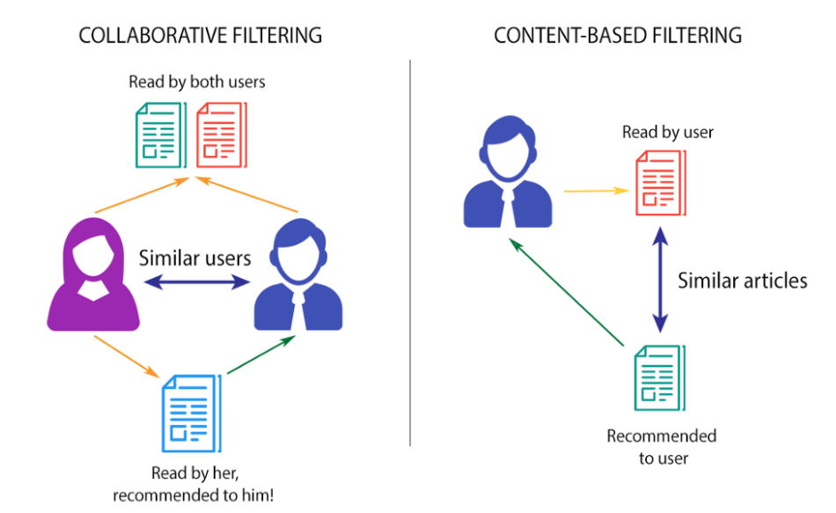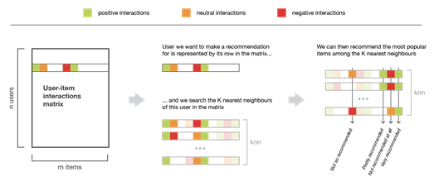

**WE ALSO USED AND EXPERIMENTED WITH COSINE SIMILARITY.**

BUT KNN using Euclidean distance seemed more appropriate measure to give recommendation in Supervised Machine learning task.

